NEWMA Professional Development Committee (PDC)
2021 Interim Meeting Agenda
Mr. Marc Paquette, Committee Chair
Vermont

INTRODUCTION
The PDC (hereinafter referred to as “Committee”) submits its Report to the Northeastern Weights and Measures Association (NEWMA). The Report consists of the NEWMA Agenda (NCWM Carryover and NEW items) and this Addendum. Page numbers in the tables below refer to pages in this Addendum. Suggested revisions to the handbook are shown in bold face print by striking out information to be deleted and underlining information to be added. Requirements that are proposed to be nonretroactive are printed in bold-faced italics.

Presented below is a list of agenda items considered by the NEWMA and its recommendations to the NCWM Professional Development Committee.
Subject Series List
Education EDU Series
Program Management PMT Series
Other Items OTH Series

Table A
Table of Contents
Reference Key | Title of Item | PDC Page
EDU – EDUCATION……………………………………………………………………………………………… 3
EDU-1 I Professional Certification Program 3
EDU-2 I Training 9
EDU-3 I Instructor Improvement 17
EDU-4 I Recommended Topics for Conference Training 19
PMT – PROGRAM MANAGEMENT 21
PMT-1 I Safety Awareness 21
PMT-2 I Skimmer Education Task Group 23
Appendices

A EDU-2: Summary of NIST OWM Trainining Conducted in 2019 27
B EDU-2: NIST OWM Training - Future Plans 30

Table B
Glossary of Acronyms and Terms

Acronym | Term | Acronym | Term
CWMA | Central Weights and Measures Association | OWM | Office of Weights and Measures
NCWM | National Conference on Weights and Measures | PDC | Professional Development Committee
NEWMA | Northeastern Weights and Measures Association | SWMA | Southern Weights and Measures Association
NIST | National Institute of Standards and Technology | WWMA | Western Weights and Measures Association
SETG | Skimmer Education Task Group

Details of All Items
(In order by Reference Key)

EDU – EDUCATION

EDU-1 I Professional Certification Program
The NCWM now offers nine professional certification exams and two basic competency exams. The certification exams include Retail Motor Fuel Dispensers, Vehicle-Tank Meters, Small Capacity Scales, Medium Capacity Scales, Large Capacity Scales, Precision Scales, LPG and Anhydrous Ammonia, Price Verification and Basic Package Checking. Reporting on the Price Verification exam begins this year and reporting on the LPG and Anhydrous Ammonia will begin next year. The competency exams include Basic Weighing Devices and Basic Liquid-Measuring Devices. Professional certifications must be renewed every five years. The NCWM has implemented a process to notify candidates whose certificates have expired.
The exams for Precision Scales and LPG and Anhydrous Ammonia were released in July 2020. Work on developing the body of knowledge for mass flow meters will begin in early 2021 followed by packaging and labeling. The Committee encourages discussion about priorities for future exams and continuous improvement of the program.
In August 2018, the NCWM Board approved the guidelines for proctoring and implemented the system. Proctoring is a vital component of plans to accredit the certification program. Each organization is required to register the proctors they intended to use. Proctor qualifications are different for basic competency exams and professional certification exams so two lists of proctors are maintained. To eliminate conflicts of interest, proctors for professional certification exams must not be immediate supervisors of the candidate.
Number of Proctors Per State (as of March 2021)
 | FY17-18 | FY18-19 | FY19-20 | FY20-21
Basic | 39 | 57 | 70 | 38
Professional | 17 | 28 | 37 | 41
Number of States with Proctors (as of March 2021)
 | FY17-18 | FY18-19 | FY19-20 | FY20-21
Basic | 10 | 14 | 18 | 18
Professional | 7 | 11 | 16 | 16
Proctors per state – Basic Competency Exams:
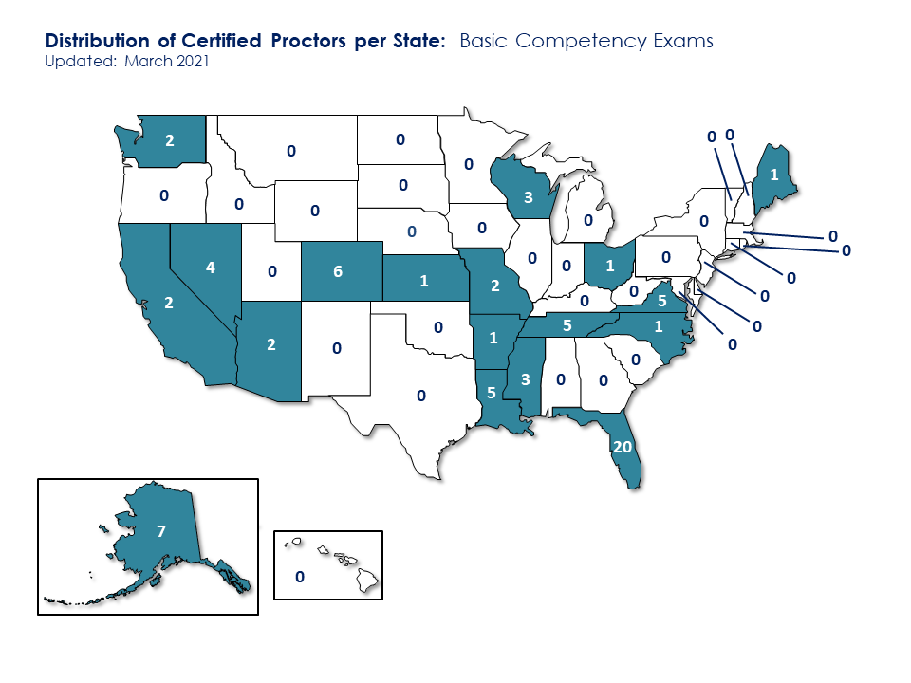
Proctors per state – Professional Certification Exams:
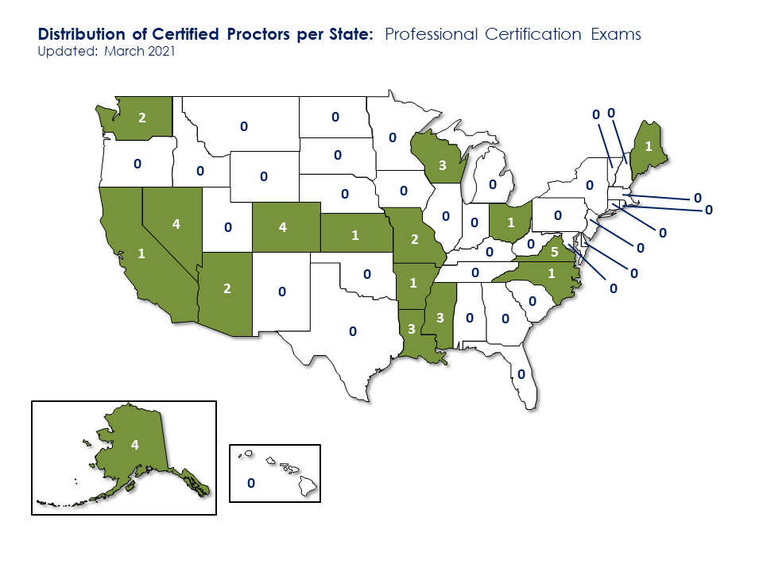
The proctor requirements are posted online at www.ncwm.com/proctoring.
Status of Current Tests
The NCWM has issued 1,152 professional certificates from the inception of the Professional Certification Program to September 30, 2020. Of the certificates issued, twelve have been issued to individuals in the private sector. The balance of the certificates has been issued to regulators. There has been a significant decline in participation in the program. In FY 17-18, NCWM awarded 257 professional certificates and in FY 18-19, it awarded 53 professional certificates, a decline of 79%. Participation improved slightly in FY 19-20 with 56 individuals earning certificates. It appears that the decline coincides with the requirement to proctor exams and the pandemic has had an impact on FY 19-20 participation. Some of the certificates have reached their 5-year expiration and certificate holders will need to seek recertification. NCWM notifies certificate holders before expiration to facilitate recertification.
NCWM Professional Certificates issued:
 | FY10-11 | FY11-12 | FY12-13 | FY13-14 | FY14-15 | FY15-16 | FY16-17 | FY17-18
Exams Passed | 44 | 94 | 105 | 62 | 198 | 140 | 142 | 257
Cumulative | 44 | 138 | 243 | 305 | 503 | 643 | 785 | 1,042
NCWM Professional Certificates issued (cont.):
 | FY18-19 | FY19-20
Exams Passed | 53 | 56
Cumulative | 1,096 | 1,152
The following map shows the states with individuals holding an active professional certificate in one or more disciplines. Please note that the twelve active certificates issued to private sector individuals are included in these figures. This data only includes certificates that have not expired as of September 30, 2021.
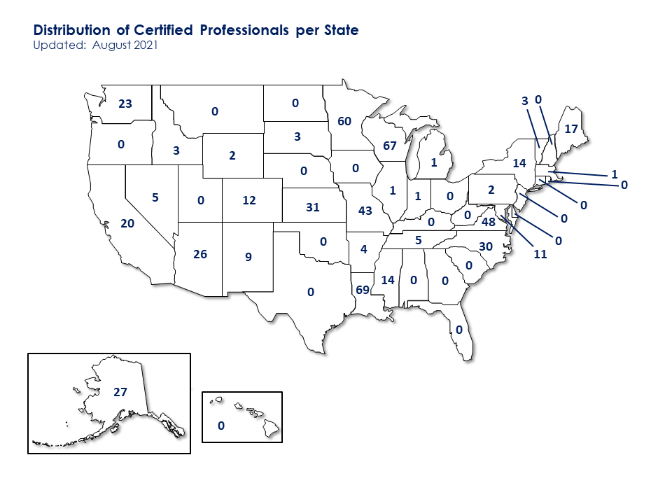
The table below shows the 37 states using the certification program and the number of certificates earned since program inception and includes expired certificates. The Committee applauds these states and encourages increased use of the certification program nationwide.
State | Certificates | State | Certificates | State | Certificates
Minnesota | 152 | Arizona | 28 | Pennsylvania | 7
Missouri | 143 | Maine | 26 | Wyoming | 7
Wisconsin | 84 | Nevada | 25 | Arkansas | 6
Maryland | 77 | New Mexico | 23 | Delaware | 4
Virginia | 70 | New York | 19 | Michigan | 3
Mississippi | 56 | Colorado | 18 | South Dakota | 3
North Carolina | 52 | Connecticut | 15 | Oregon | 2
Washington | 50 | Indiana | 13 | Tennessee | 2
Kansas | 45 | Ohio | 13 | Montana | 1
California | 41 | Private | 12 | New Hampshire | 1
Louisiana | 40 | Idaho | 11 | West Virginia | 1
Alaska | 42 | Massachusetts | 11
Nebraska | 33 | Vermont | 8
NCWM Basic Competency Certificates issued:
 | FY17-18 | FY18-19 | FY19-20 | FY20-21
Exams Passed | 1 | 64 | 25 | 102
Cumulative | 1 | 65 | 90 | 192
The table below shows those states with the highest utilization of the Basic Exams Program. The Committee applauds these states and encourages increased use of the certification program nationwide.
State | Certificates
Tennessee | 42
Louisiana | 45
Alaska | 6
Colorado | 3
Florida | 3
Nevada | 2
Kansas | 1
The following graphs show the impact of the pandemic on certifications issued.
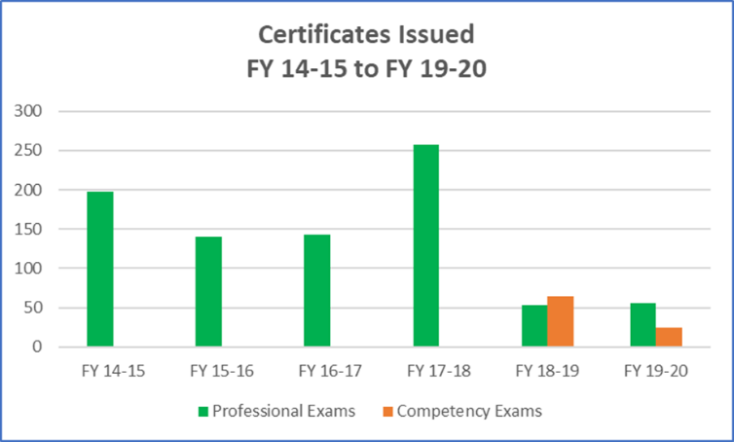
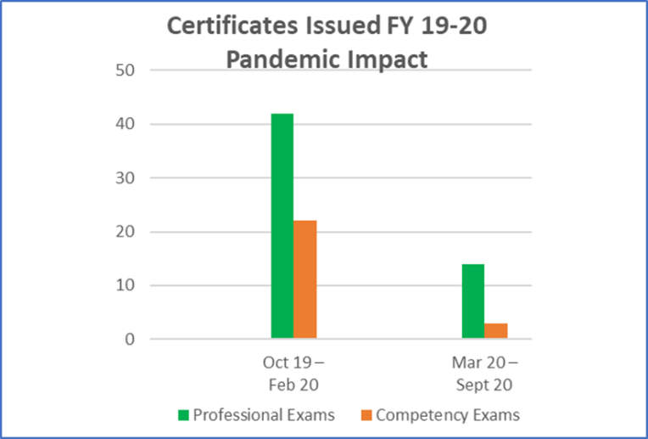
NCWM Meeting Comments:
NCWM 2021 Interim Meeting: The 2021 Interim Meeting was held virtually and immediately following the conclusion of the NCWM 2020 virtual meeting.

Mr. Robert Huff (DE) asked if NCWM had considered removing the requirement for proctoring. Mr. Hal Prince (FL) indicated the Board discussed this possibility and the suspension of this requirement would jeopardize the integrity of the exams and would preclude ever reaching accreditation. We are actively pursuing online proctoring and are hopeful this is something that can be offered soon. Mr. Huff pointed out the decline in participation is obvious and those that would like to renew are quite possibly unable to do so. Mr. Ethan Bogren (Westchester Co., NY) indicated his support for exploring remote proctoring and that currently, lack of access to proctoring is preventing access to the exams for his jurisdiction. Mr. Brogan continued to suggest if access to the exams and/or proctoring was offered as a benefit of NCWM membership, it could be of value to inspectors, and promote growth of the membership. Ms. Kristin Macey (CA) asked how remote proctoring would work. Mr. Jerry Buendel (Certification Coordinator) indicated there are several providers and tiers of service and they are all being explored. Ms. Angela Godwin (Ventura Co., CA) indicated remote proctoring is a real need.

During the committee work session on January 14, 2021, the members reviewed the post exam surveys provided by NCWM. Mr. Buendel compiled the results and presented the information to the committee. The Committee observed that too few examinees were reviewing the learning objectives in the respective exam module prior to taking the exam. The Committee recommended a review the NCWM website to determine if examinees were clearly instructed to review the modules and if the modules were easily accessible. Two survey respondents indicated that it would be beneficial to have a two-step process to indicate that they had completed the section and that their submissions were final. Mr. Paul Floyd (LA) commented that Louisiana was requiring more inspectors to take exams. Mr. Floyd noted that the inspectors had a better grasp of the principles of operation and device exam requirements and as a result were doing more thorough inspections and were more confident in their findings and determinations.
The members of the Professional Development Committee also discussed the expiration dates of individual certifications during the work session. The Committee recommends that the Board of Directors take action to extend the dates of all certifications expiring between March 2020 and August 2021 to September 2021. The Committee recognized the difficulties of taking the exams because of restrictions caused by the pandemic as well as the barriers associated with proctoring. The Committee noted that some jurisdictions or service companies may be using the exams to justify promotions or require an employee maintain current certification(s) in order to maintain their current job classification and salary. Mr. Jerry Buendel (Certification Coordinator) stated that the tests are reviewed annually to determine if any changes made to the Handbooks would require changes to the exam questions. Mr. Buendel went on to say that in the past three years he has made only two changes to current exam questions. The Committee also discussed the precedent that would be set by extending the expiration and concluded that the current extraordinary circumstances warrant an extension.
NCWM 2021 Annual Meeting: The 2021 Annual Meeting was held in an in person and online hybrid meeting session. Comments were received in person and from members online. Several comments were heard about the difficulty and scope of the exams, particularly when qualifying Registered Service Agents (RSAs). Mr. Scott Simmons (CO) reported that Colorado tried to use the measuring basic competency exam as part of their RSA licensing program. Of the three service companies that had technicians attempt the exam, there was a high failure rate and Colorado concluded that it was too difficult, and too broad in scope for the purpose of RSA licensing. Mr. Simmons suggested that an exam that was narrower in scope could be used for testing RSAs in Colorado. Mr. Greg VanderPlaats (MN) said that the basic competency exams are too broad for use in registering or licensing service technicians, specifically those who specialize in a single device type or class. They also do not charge their RSAs when testing, so moving to the NCWM test would result in incurring a charge that does not currently apply. Mr. VanderPlaats also thanked the Board for approving virtual proctoring and encouraged their continued use. Mr. Kevin Schnepp (CA) added that the general basic competency exams would not work for state licensing requirements and suggested the exams be written for specific device types. Mr. David Boykin (NCR) stated the basic competency exam was too broad. NCR deals with POS systems and the exam covers devices not serviced by NCR technicians. Mr. Loren Minnich (KS) testified that the state laws and regulations were a barrier to using the current basic competency exams. There is some privatization in Kansas and some businesses service very specific device types such that a general exam would not always be appropriate and in some cases, Kansas provides a special exam. Mr. Minnich suggested that there be a way to mark questions during an exam that the test taker thought should be reviewed by NCWM for clarity and consistency.

Mr. Minnich asked about the importance of accreditation. Mr. Jerry Buendel (Certification Coordinator) explained that accreditation would give the program additional credibility and would assure that we have rigorous processes in place to operate the testing program.
Mr. Paul Floyd (LA) suggested the exams and questions be reviewed periodically and was concerned about the question review process’s impact on accreditation. Mr. Tim Chesser (AR) asked what certification meant and why certifications are good for five years. Mr. Buendel explained that certification demonstrates a thorough understanding of the national technical requirements and their application in regulatory inspections. Five years was selected based on the rate of change to the Handbooks and logical best fit for time between tests.
Mr. Kurt Floren (Los Angeles Co., CA) suggested we consider dividing exams to have one section cover specific devices and another section tailored to cover a jurisdiction’s laws and regulations both exams should include input from the respective state. For example, there could be a pool of 100 questions, and the state could select from these and add their own state-specific requirements questions.
Mr. Chesser asked where we found Subject Matter Experts (SMEs). Mr. Buendel stated that there are various means of identifying SMEs including a request for assistance via the list serve, participation in the conference, and by their reputation in the weights and measures community.
Ms. Cheryl Ayer (NH) asked if it would be best to have some weights and measures officials take the competency exams so they can see what it entails to determine whether or not it will serve well for their service agents. Mr. Buendel appreciated the suggestion and agreed that it would be helpful.
Ms. Tina Butcher (NIST OWM) shared that there has been some reluctance from state weights and measures officials to use the same test for state inspectors and RSAs. The Committee also heard comments that some jurisdictions have privatized and/or delegated some functions to RSAs.
During its work session, the Committee decided to recommend the Board of Directors consider authorizing a work group to investigate further refining the NCWM testing program to include licensing programs for RSAs that could be utilized by individual states. This work group could address such issues as the need for additional, more specific competency exams, and variations in jurisdictional requirements and how to address these to make the test more applicable to RSAs. The Committee also reviewed the results of the exam post exam surveys.
Regional Association Comments:
WWMA 2020 Annual Meeting: No comments were received during open hearings regarding this item. The Committee recognizes the tremendous advantages and value of the NCWM’s Professional Certification Program and appreciates the work that many in the community have contributed to the continued operation of the program. The Committee has read with interest the concerns that some have raised regarding the use of proctors and encourages the NCWM PDC to review this element of the program.
SWMA 2020 Annual Meeting: Chairman Paul Floyd (LA) commented that efforts would be made to update the information in this item for the NCWM Annual Meeting. Ms. Tina Butcher (NIST OWM) commented that the Western Association meeting discussed issues evolving around proctoring exams and additional resources from outside agencies that may need to be acquired. At the WWMA, several jurisdictions shared best practices and approaches for securing proctors. Ms. Butcher also noted the NCWM PDC would be interested in hearing the experiences of and input from SWMA members on this issue. Mr. Paul Floyd (LA) commented that Louisiana has added another testing center, a smaller college in Central Louisiana, for both basic and professional exams. Mr. Ken Ramsburg (MD) commented that they found proctoring was an issue since their Department of Agriculture in Maryland is relatively small and they were looking for outside sources to assist in administering the exams. Mr. Ramsburg added that the PDC and NCWM missed an opportunity for more exams to be taken by not offering them in an easily accessible online format.
NEWMA 2020 Interim Meeting: During its open hearings, the Committee heard comments related to the implementation of proctoring for the NCWM Professional Certification Program Exams. Mr. Don Onwiler (NCWM) commented that jurisdictions are using various approaches to implement proctoring and shared an example of one state that is making use of universities and learning centers for this purpose, which Mr. Onwiler is happy to authorize. Mr. Onwiler noted there may be a cost for some of these proctoring arrangements and suggested that jurisdictions might consider exploring the possible use of AMC funds for training toward these costs. Ms. Tina Butcher (NIST OWM) noted that during discussions at the recent Western and Southern Weights and Measures Association Meetings, jurisdictions shared different approaches they have used for proctoring. Ms. Butcher suggested that perhaps this kind of shared information of best practices might be beneficial for jurisdictions seeking options to implement this. Mr. Ross Andersen (NY, Retired) commented that there is a wealth of information and guidance on the NCWM website to assist jurisdictions in the process of securing proctors for these examinations. Mr. James Cassidy (MA) acknowledged the difficulty in coordinating proctoring. Particularly with the restrictions of the pandemic, certification and testing of inspectors seems to be at a standstill right now. Mr. Cassidy encouraged the Committee to pursue the idea of exploring the use of AMC funding to help jurisdictions certify its inspectors. PDC Chair, Mr. Marc Paquette (VT) observed there is a need to ensure the integrity of the examination process. Regarding virtual training, he noted that Ms. Butcher will share some of NIST’s work in this area as part of the Committee’s next item.
Committee recognizes the advantages and value of the NCWM’s Professional Certification Program and appreciates the work that many in the community have contributed to the continued operation of the program. After hearing some of the concerns regarding the use of proctors, the Committee encourages the NCWM PDC to review this element of the program to identify additional ways to assist jurisdictions in implementing it. Committee acknowledges that the COVID-19 pandemic and its associated restrictions have been a setback to jurisdictions in many regards, particularly in the areas of training and certification. The Committee also suggested that the NCWM Board of Directors may wish to revisit the issue of proctoring and consider relaxing the proctoring until such time that jurisdictions can more readily implement it
CWMA 2020 Interim Meeting: Mr. Don Onwiler (NCWM) shared that both Arkansas and Louisiana have asked for universities to be authorized to provide proctoring and have been granted that request. Mr. Onwiler mentioned that this may be an option for other states to explore as well. Mr. John Albert (MO) added via Zoom chat that Missouri’s HR department has agreed to proctor the exams for their employees. Ms. Sherry Turvey (KS) and Ms. Brenda Geist (KS) reported that their HR department will not provide proctoring, but Barton County Community College has agreed to proctor and is charging by the hour. Ms. Rachelle Miller (WI) added that they have had a difficult time with proctoring with the pandemic restrictions but had been able to proctor themselves with the aid of other divisions. Ms. Miller also commented that the City of Milwaukee has done the same. Mr. Onwiler (NCWM) noted he has suggested that the states that are having issues with proctoring on a large scale could apply for Associate Membership Committee (AMC) funding for this purpose.
Mr. Greg VanderPlaats (MN) shared the fact that Minnesota has not done any professional certification tests since the proctoring requirement was put in place. They used the testing heavily before that but are having difficulties finding the time to find anyone to proctor for them.

EDU-2 I Training
The purpose of this item is to share best practices and approaches to training in response to the broad training needs of weights and measures jurisdictions and to serve as a link to various training materials on the web.
At the 2019 Interim Meeting, the Committee was asked to consider reviewing and potentially updating/reintroducing the old NIST OWM training modules. The Committee agreed to investigate whether these modules are still available in digital form. Mr. Ross Andersen (NY, Retired) indicated that NIST has extensive training materials that we could leverage; requesting these materials from NIST may be beneficial.
The Committee also heard updates from several sources announcing upcoming device training hosted by Kansas and about upcoming combined NIST regional weights and measures metrology training. Three states recommended that NCWM and NIST OWM consider joint development of training videos and investigate funding from additional sources such as grants.
Ms. Butcher provided the following “Summary of NIST OWM Training Conducted in 2020” along with information regarding other training and professional development resources OWM has provided for weights and measures jurisdictions and service companies in the past year, including projects to assist those whose activities were restricted due to the COVID-19 pandemic.
Summary of NIST OWM Training Conducted in 2020
Area/Course Name | Start Date | Location | No. of  Students
Laboratory Metrology
Balance & Scale Calibration Uncertainties | 01/27/20 | Gaithersburg, MD | 8
Fundamentals of Metrology | 02/03/20 | Gaithersburg, MD | 8
 | 02/10/20 | Gaithersburg, MD | 8
Fundamentals of Metrology & LAP Problems Preparation | 09/16/20 | Web-based | 8
Mass Metrology Seminar | 03/02/20 | Gaithersburg, MD | 8
Regional Measurement Assurance Programs
MidMAP | 10/06/20 | Web-based | 24
NEMAP | 04/20/20 | Web-based | 16
SEMAP | 04/20/20 | Web-based | 33
SWAP | 05/04/20 | Web-based | 24
WRAP | 05/04/20 | Web-based | 27
Webinars
Basic Uncertainty Concepts | 03/05/20 | Web-based | 3
Calibration Certificate Evaluation | 02/25/20 | Web-based | 12
Conducting an Effective Management Review | 02/13/20 | Web-based | 12
Info Hour – Mentoring and On-the-Job Training | 08/04/20 | Web-based | 58
Info Hour – Quality Management System & SAP Reviews | 10/13/20 | Web-based | 58
Internal Auditing Best Practices | 02/27/20 | Web-based | 14
Software Verification & Validation | 02/20/20 | Web-based | 6
State Laboratory Annual Submission Process | 09/10/20 | Web-based | 95
Laws and Metric Program
Packaging & Price Verification
Handbook 130 – Examination Procedure for Price Verification  13 Sessions: 03/25/20; 04/08/20; 04/13/20; 04/14/20; 04/16/20; 04/20/20; 04/21/20; 05/19/20; 06/16/20; 07/22/20; 09/22/20; 10/14/20; 12/01/20 | 13 sessions May to Dec. 2020 | Web-based | Total 599
Handbook 130 – Overview of the Uniform Packaging and Labeling Regulation  11 Sessions: 03/26/20; 04/09/20; 04/15/20; 04/17/20; 04/22/20; 04/24/20; 05/21/20; 06/17/20; 07/23/20; 10/14/20; 12/1/20 | 11 sessions Mar. to Dec.  2020 | Web-based | Total 562
Handbook 133 – Checking the Net Contents of Packaged Goods  8 Sessions: 04/23/20; 04/27/20; 04/29/20; 04/30/20; 05/20/20; 06/18/20; 08/05/20; 10/15/20 | 8 sessions Apr. to Oct.  2020 | Web-based | Total 420
Handbook 133 – How to Test Animal Bedding  6 Sessions: 09/21/20; 09/30/20; 10/08/20; 10/21/20; 11/18/20; 12/09/20 | 6 sessions Sep. to Dec.  2020 | Web-based | Total 179
Handbook 133 – Overview of Handbook 133 | 12/03/20 | Web-based | 74
Weights and Measures Inspections – Evidence, Search and Seizure, and Due Process  6 Sessions: 09/22/20; 10/01/20; 10/08/20; 10/20/20; 11/17/20; 12/08/20 | 6 sessions Sep. to Dec.  2020 | Web-based | Total 613
Metric Education
Info Session – Metric Education Resources | 09/12/20 | Web-based | 9
 | 09/30/20 | Web-based | 6
Info Session – Metric Estimation | 09/16/20 | Web-based | 4
 | 09/26/20 | Web-based | 6
Measurement System Basics – SI and US Customary Units for Regulatory Officials | 08/12/20 | Web-based | 65
 | 10/21/20 | Web-based | 68
Legal Metrology Devices
No training seminars were offered in 2020. | -- | -- | --

A summary of activities in each OWM Program area follows:
Laboratory Metrology Program
The following summarizes activities in the NIST OWM Laboratory Metrology Program:
General. The Laboratory Metrology Program conducted several in-person classes prior to the COVID-19 pandemic restrictions imposed in March 2020. This program also developed a web-based Fundamentals of Metrology and LAP Problems Preparation Course. These courses will be used to provide formalized training to new Metrology staff until in-person training resumes.
OWM is also pleased to announce that Dr. Michael Hicks was appointed as Program Leader for the NIST OWM Laboratory Metrology Program in Fall 2020.
Regional Metrology Association Training. All regional metrology association training was converted to a virtual format and the training was conducted online. Special topics included “Roundtable Discussions” and “Proficiency Testing Reporting and Planning.”
Upcoming Lab Program Training. The Laboratory Program is continuing to schedule online training as outlined in the OWM Calendar of Events. The Program is scheduling some on-site training for June 2021; however, the plans to conduct this training on-site is contingent upon the re-opening of the NIST campus. As the date of the training approaches, there may be a need to shift the training to a virtual format. Consequently, registered students are cautioned NOT to make travel arrangements pending written confirmation. Note that the decision to propose this particular training in an in-person format so far in advance in light of the uncertainty of conditions is based on the States’ laboratory metrologists’ dependency on training required for designated signatories for calibration services and OWM’s long lead time for securing contract trainers.
Laws and Metric Program
General. The Laws and Metric Program cancelled all previously scheduled in-person courses as of April 2020 due to the COVID-19 pandemic. As of June 2020, OWM opened its webinars to industry at no charge. All “in-person” field inspection classes are postponed until further notice. OWM is not currently scheduling any in-person field inspection classes for the 2021 calendar year.
Webinar Offerings. Since April 2020, a total of 2,352 students have participated in Laws and Metric Program webinars. This includes training for 2194 students in the area of Laws and Regulations and training for 158 students in other Laws and Metric Program areas.
In April 2020, the Laws and Metric Program’s Mr. David Sefcik began offering three previously developed webinars and continued offering these at periodic intervals through December 2020.

- Examination Procedure For Price Verification, HB 130 (2 hr.)
- Overview of the HB 130 Uniform Package and Labeling (UPLR) and Uniform Method of Sale (MOS) of Commodities Regulations (2 hr.)
- Handbook 133 – “Checking the Net Contents of Packaged Goods - Overview” (2.5 hr.)
In September 2020, the Laws and Metric Program began offering three new webinars developed by Mr. Ken Butcher and presented by Mr. David Sefcik. These were offered at periodic intervals through December 2020.
- Handbook 133 – How to Test Animal Bedding
  - Covers the different types of animal bedding, method of sale, test equipment, audit and test procedure, and documentation and evaluation of test results.
- Handbook 133 – Overview
  - Covers the different types of mulch and soil and how they are sold (method of sale), the labeling requirements, test equipment, sampling (and alternative sampling), test procedure, and evaluation of test results.
- Weights and Measures Inspections – Evidence, Search and Seizure, and Due Process
  - Provides an overview on how the U.S. Constitution, the Bill of Rights, Laws, and Court decisions control how weights and measures inspections must be conducted. You will learn about the powers and duties of the Director and the special police powers of an official, as outlined in Handbook 130, Uniform Weights and Measures Law.
  - Topics include a checklist for “opening” and “closing” an inspection; consent; search and seizures under the 4th Amendment of the U.S. Constitution; defining evidence and provide suggestions on collecting, protecting, and using it to support enforcement actions evidence; enforcement actions and recommended compliance procedures; and model guidelines for the administrative review process.
Legal Metrology Devices Program
General. As with the two other OWM program areas, the Devices Program was forced to postpone the following training courses originally scheduled during the period of April 2020 to May 2021:
- High Precision Scales (CWMA)
- Vehicle Scales (VA)
- Liquefied Petroleum Gas Liquid-Measuring Devices (SD)
- Retail Motor-Fuel Dispensers (LA)
- Vehicle-Tank Meters (CA)
- Vehicle-Tank Meters (AL)
All “in-person” field inspection classes are postponed until further notice. OWM is not currently scheduling any in-person field inspection classes for the 2021 calendar year.
While the Devices Program did not have materials ready to present in a virtual format, the Devices Program staff worked to develop other tools and information that could assist weights and measures officials and service personnel working from home on their personal professional development during the restrictions of the pandemic. The Devices Program is exploring the development of webinars in the device inspection area.
Study Guides. Mr. John Barton, Ms. Tina Butcher, and Ms. Diane Lee of the Devices Program staff along with Ms. Lisa Warfield of the Laws and Metric Program staff developed a series of seven “study guides” to assist field inspectors and service personnel working from home or otherwise restricted from routine activities during the COVID-19 pandemic. These study guides are designed for use by weights and measures officials and service personnel to enhance and strengthen their knowledge of specific areas of legal metrology inspection and testing and are intended for use even after the restrictions of the pandemic are lifted.
The study guides are not intended to be a comprehensive summary of all training and development opportunities recommended for inspectors working in a specific topic area. Rather, they are intended to help individuals in their professional development by targeting the use of information and resources available on the NIST OWM website. Study guides are particularly ideal for use by individuals who are working remotely and are striving to enhance and strengthen their technical knowledge.
Included in each study guide are the following:
- An overview of resources available on the NIST OWM website, including self-study course material; videos; and newsletter articles and guidance documents on legal metrology issues.
- Suggestions for how each of these resources might be used for either independent, individual study or by groups of inspectors/service personnel led by an instructor or supervisor.
- Information on other training opportunities, including both on-line training and in-person instructor-led training and other resources for professional development.
- These study guides are intended for use in conjunction with other resources on the NIST OWM website, including Handbooks 44, 130, and 133.
Study guides have been developed and posted on OWM’s web site for the following field inspection areas:
- Grain Moisture Meters and NIR Grain Analyzers
- Measuring – Retail Motor-Fuel Dispensers
- Measuring – Large Meters
- Measuring – Liquefied Petroleum Gas Liquid-Measuring Devices
- Packaging and Labeling Inspections
- Weighing – Small Scales
- Weighing – Large Scales
These study guides are available for download free of charge at following link:
https://www.nist.gov/pml/weights-and-measures/legal-metrology-devices/training-materials#studyguides
Technical Article and Knowledge Check for Self-Study. Mr. Rick Harshman of the Devices Program developed a Technical Article titled “Making Sense of “Min” on Class I and Class II Scales.” This explains the concept of “Min” and provides guidance on its use and application in transactions encountered by jurisdictions which are reportedly regulating a growing number of Class I and Class II scales.
Mr. Rick Harshman and Ms. Tina Butcher also developed a new feature called a “Knowledge Check” to accompany this article. The Knowledge Check serves as a tool for jurisdictions who might want to quiz their employees on their knowledge retention after assigning them the task of reading the article. Depending on feedback, the Devices Program may include Knowledge Checks as a regular accompaniment to its technical articles.
General – OWM Training
Ms. Butcher reported all NIST OWM “in-person” field inspection classes are postponed until further notice. OWM is not currently scheduling any in-person field inspection classes for the 2021 calendar year. This does not include the training referenced under the Laboratory Metrology Program’s summary that is tentatively scheduled for June 2020 if conditions permit.
OWM is not currently making specific commitments for field inspection training pending changes in restrictions related to the COVID-19 situation that would help ensure the safety of its students and staff involved in such training and traveling to attend these events. OWM will continue to assess these conditions as the situation unfolds.
It is unclear how pandemic-related restrictions will affect OWM’s in-person training in the future. The decision to resume in-person classes will be driven by Centers for Disease Control recommendations local pandemic restrictions, and travel restrictions for staff and students. OWM is also considering the impact of social distancing requirements on classroom size and configuration and ability to present to groups.
In the meantime, OWM will continue to offer virtual training and plans to expand its offerings. Ms. Butcher encouraged those interested in upcoming training to consult OWM’s Calendar of Events for the most current information:
https://www.nist.gov/news-events/upcoming-events/org/6436
Ms. Butcher shared that, in the latter months of 2020, a team of training developers and facilitators within OWM begun working to consider how OWM might restructure its training program to include more virtual offerings. In addition to considering which existing (or yet-to-be-developed) courses might lend themselves to training in a virtual format, this team has discussed the importance of incorporating some equivalent of the “hands-on” element that is a cornerstone of field inspection courses and the distinction between training and technical presentations. OWM is exploring the idea that, should resources permit it, it may be possible to record some webinar offerings at some point in the future; these could possibly be made available “on demand” and accompanied by periodic question and answer sessions with a live instructor. OWM is continuing to explore the use of technology and available features to adapt its courses to a virtual format and is also considering whether a “hybrid” approach might be used in which a portion of an existing course could be presented virtually and followed by smaller, in-person classes to incorporate a hands-on demonstration and student assessment.
While this shift in thinking was driven initially by the restrictions of the COVID-19 pandemic, OWM has recognized the value of providing virtual courses and training events as a way of providing more training opportunities to a larger number of OWM customers. Thus, while OWM expects to resume offering in-person training opportunities when conditions once again permit, OWM sees the value of continuing to include a virtual component to its training even when pandemic restrictions are lifted.
As OWM considers how to best expand its virtual training offerings, OWM staff have been experimenting with available technology and tools to best incorporate elements of “hands on” activities that are so important to its field inspection training courses. OWM is also considering the development of “hybrid” courses in which virtual sessions are coupled with “hands on” sessions using virtual technology and/or local onsite trainers to help facilitate these sessions. Such hybrid courses would be intended for use both during the COVID-19 pandemic and after the associated restrictions are lifted.
Ms. Butcher reported that NIST OWM is outfitting a space at NIST OWM specifically suited to conduct virtual training events and web-based meetings. OWM trainers are continuing to participate in a variety of training courses as part of their own professional development, including education in virtual training design, development, and delivery as well as instructional design.
Ms. Butcher once again thanked the jurisdictions who have hosted the many “in-person” NIST training seminars in the past, recognizing the effort required to host these events and coordinate the logistics. She also recognized co-instructors who have assisted in presenting these events. NIST OWM looks forward to continued work with the weights and measures community to develop and implement training to assist weights and measures officials and service personnel in their continued professional development.
NCWM Meeting Comments:
NCWM 2021 Interim Meeting: The 2021 Interim Meeting was held virtually and immediately following the conclusion of the NCWM 2020 virtual meeting. Ms. Cheryl Ayer (NH) asked if NIST OWM was continuing work on providing an on-demand video for small capacity scale field inspection. Dr. Doug Olson (NIST OWM) and Ms. Tina Butcher (NIST OWM) both indicated the plan was to continue that project. Multiple comments from the membership were heard thanking NIST OWM for the training provided. The comments indicated this training was invaluable during the pandemic.
NCWM 2021 Annual Meeting: The 2021 Annual Meeting was held in an in person and online hybrid meeting session. Comments were received in person and from members online. During the 2021 Annual Meeting open hearings an updated presentation was given on NIST training activity. The updates have been included in Appendix B of this report.
Ms. Cheryl Ayer (NH) indicated her support for hybrid and virtual training and pointed out that there is cost savings with no need to travel, etc.
Regional Association Comments:
WWMA 2020 Annual Meeting: Ms. Tina Butcher (NIST OWM) provided a presentation on NIST OWM training activities during the period of January to July. Ms. Butcher noted that this presentation was provided during the NCWM PDC’s virtual meeting in July 2020. Ms. Butcher highlighted OWM’s efforts to support weights and measures jurisdictions by providing training and other professional development materials in a virtual format during the time that restrictions of the COVID-19 pandemic prevented field inspectors and service personnel from working in field installations.
Ms. Butcher also noted OWM is taking the opportunity to consider how this virtual training might be incorporated into OWM’s regular training offerings and rather than just adding in virtual classes. OWM is trying to be strategic in considering how virtual offerings can be integrated into OWM’s overall training program even following the pandemic. In the future, OWM may offer multiple formats and consider hybrid approaches such as presenting the lecture portions online and conducting hands-on portions in person with smaller classes held back-to-back. OWM is considering various approaches that might not only help its trainers to continue to provide training during the pandemic restrictions, but that would also allow OWM to reach more people than is possible with in-person classes alone. OWM is mindful that a very important part of the in-person classes is the hands-on portion, so it is necessary to consider different options to ensure what is provided will still meet the needs of the jurisdictions and students. There may be various combinations of options that could be used.
The Committee heard comments from Ms. Cadence Matijevich (NV) who commented that Nevada appreciates all the work that NIST did to provide virtual training during the pandemic. The options provided allowed field inspectors who were not able to do normal inspection work to spend time on professional development, making lemonade out of lemons. She expressed an appreciation for all the training and resources provided by NIST OWM. Ms. Michelle Wilson (AZ) echoed Cadence’s comments. Ms. Wilson asked if NIST has considered recording training events and posting the videos as “on demand” training, noting this would be particularly helpful for new inspectors. Ms. Wilson also asked about the use of field trainers to supplement the “hands on” portion of classes, with the idea that the field trainers might be able to conduct demonstrations to accompany the online training. Ms. Kathy de Contreras (CA) encouraged NIST to continue to offer these types of classes and the use of webinars and “train-the-trainers”.
Ms. Butcher noted OWM has considered the idea of on-demand training. A drawback, particularly for more complex topics is the lack of ability for a student to ask questions during the seminar. However, OWM has also considered the idea of developing recorded presentations and supplementing that with periodic Q&A sessions as a follow-up. Ms. Butcher noted OWM is also open to ideas for ways to incorporate alternatives for the hands-on portions through video and other technology links with field sites.
SWMA 2020 Annual Meeting: Ms. Tina Butcher (NIST OWM) gave a presentation on EDU – 2 which included an overview of web-based training and other developmental resources offered by NIST OWM between January and July 2020. The presentation gave statistics on participants the program reached. Mr. Paul Floyd (LA) thanked Ms. Butcher and NIST OWM for developing and offering the webinars. Mr. Phillip Wright (TX) followed up with comments thanking Ms. Butcher and NIST OWM and that he was encouraged to see the direction of the training program. Mr. Ken Ramsburg (MD) again thanked NIST OWM for being supportive and producing a robust training program and said he and his staff appreciated the trainings and attended trainings for price verification, and Laboratory Metrology. Mr. Ramsburg also commented that webinars for Service Companies and Technicians would be beneficial beginning with the retail motor fuel dispenser companies. Mr. Ramsburg noted that, due to pandemic restrictions, service companies are not attending their jurisdiction’s normal service person training; with the relatively high turnover in the service industry, this has created a gap in service personnel’s knowledge of legal metrology requirements. Mr. Ed Coleman (TN) thanked NIST OWM for the trainings and agreed with Mr. Ramsburg that a webinar program for Service Companies and Technicians would be a great addition.
NEWMA 2020 Interim Meeting: Ms. Tina Butcher (NIST OWM) provided a presentation on NIST OWM training activities during the period of January to July. Ms. Butcher noted that this presentation was provided during the NCWM PDC’s virtual meeting in July 2020. Ms. Butcher highlighted OWM’s efforts to support weights and measures jurisdictions by providing training and other professional development materials in a virtual format during the time that restrictions of the COVID-19 pandemic prevented field inspectors and service personnel from working in field installations. Ms. Butcher noted the shift to include more virtual training options has a profound impact on OWM’s ability to reach more people than it can for in-person classes alone. Ms. Butcher also noted OWM is taking the opportunity to consider how this virtual training might be incorporated into OWM’s regular training offerings rather than just adding in virtual classes. OWM is considering how virtual offerings can be integrated into OWM’s overall training program even following the pandemic. In the future, OWM may offer multiple formats and consider hybrid approaches such as presenting the lecture portions online and conducting hands-on portions in person with smaller classes held back-to-back. OWM is considering various approaches that might not only help its trainers to continue to provide training during the pandemic restrictions, but that would also allow OWM to reach more people than is possible with in-person classes alone. OWM is mindful that a very important part of the in-person classes is the hands-on portion, so it is necessary to consider different options to ensure what is provided will still meet the needs of the jurisdictions and students. There may be various combinations of options that could be used.
The Committee heard comments from Ms. Cheryl Ayer (NH) who expressed interest in having this training available to service agencies and the possibility of including online videos of the webinars that could be viewed by service agencies. Ms. Butcher noted that, while NIST’s training has been oriented to support regulatory officials in their implementation of NIST standards and test procedures, industry has been welcomed into many classes and NIST would continue to do so. Ms. Butcher commented that having an industry presence in classes has been very beneficial to both the industry participants and regulators alike. Ms. Butcher noted OWM has discussed the possibility of recording webinars for future viewing and work is underway in one area of training to explore this possibility. In the meantime, OWM will focus on increasing its virtual options. Ms. Butcher also noted that, given the complexity of the material, students will likely have questions about specific elements of a training session. OWM is considering how to incorporate this into its structure, considering possibilities such as posting of frequent questions supplemented by periodic live question and answer webinar sessions on a given class with a live instructor. Mr. Ross Andersen (NY, Retired) commented that he has developed and posted videos on YouTube on the technical issue of “d” and “e” and encourages others to share similar technical topics via YouTube. While not speaking to the videos posted by Mr. Andersen, Ms. Chery Ayer (NH) commented jurisdictions need to ensure the validity and accuracy of procedures illustrated in videos posted on YouTube. Mr. Andersen noted the authors of such videos would need to take responsibility for ensuring that accuracy.
PDC Chair, Mr. Marc Paquette (VT) observed his staff found the NIST offerings to be very beneficial and made specific recognition of a newly offered NIST OWM webinar on Evidence, Search and Seizure, and Due process. He encouraged members to check out the virtual offerings NIST is providing. The Committee greatly supports the ongoing efforts of NIST OWM in modifying its training opportunities to include more virtual options, particularly during the COVID-19 pandemic; this training has met the need of many jurisdictions who have relied on this during the restrictions brought on by the pandemic. The Committee encourages jurisdictions and industry to consider the use of web-based platforms to extend their own training opportunities through group sessions and training as well as take advantage of videos and other training resources available online.
CWMA 2020 Interim Meeting: Ms. Tina Butcher (NIST OWM) provided a presentation on NIST OWM training activities during the period of January to July. She noted that this presentation was provided during the NCWM PDC’s virtual meeting in July 2020 and at the three prior regional weights and measures association meetings. Ms. Butcher highlighted OWM’s efforts to support weights and measures jurisdictions by providing training and other professional development materials in a virtual format during the time that restrictions of the COVID-19 pandemic prevented field inspectors and service personnel from working in field installations. She noted the shift to include more virtual training options has a profound impact on OWM’s ability to reach more people than it can for in- person classes alone. Ms. Butcher also noted OWM is taking the opportunity to consider how this virtual training might be incorporated into OWM’s regular training offerings and rather than just adding in virtual classes. OWM is considering how virtual offerings can be integrated into OWM’s overall training program even following the pandemic. In the future, OWM may offer multiple formats and consider hybrid approaches such as presenting the lecture portions online and conducting hands-on portions in person with smaller classes held back-to-back. OWM is considering various approaches that might not only help its trainers to continue to provide training during the pandemic restrictions, but that would also allow OWM to reach more people than is possible with in-person classes alone. OWM is mindful that a very important part of the in-person classes is the hands-on portion, so it is necessary to consider different options to ensure what is provided will still meet the needs of the jurisdictions and students. There may be various combinations of options that could be used.
Ms. Elizabeth Lambert (MO) noted in Missouri, Lab Manager, Mr. Kevin Upshulte (MO) and several of their inspectors have taken the “Evidence, Search, and Seizure” online course and they all said it was great and they got a lot out of information out of the course. Ms. Butcher noted she will share this feedback with the NIST OWM team responsible; Mr. Ken Butcher, who developed the webinar, and Mr. David Sefcik, who has been presenting it. Mr. Doug Rathbun (IL) thanked Ms. Butcher and all the people at NIST for their hard work. Illinois’ program has two metrology staff members in training who are anxious to get back to in-person training and they all appreciate how NIST has stepped up in this and other arenas to present online training. Mr. Ivan Hankins (IA) concurred and shared he also participated in the “Search and Seizure” webinar and found it jam packed with information. Mr. Hankins would like to take the seminar again to catch anything he may have missed while taking notes. Mr. Hankins noted Mr. David Sefcik (NIST OWM) is a wonderful instructor and NIST has done a great job with this. Mr. Hankins asked if there might be a possibility of having “private tutoring” once you are able to travel. For example, Mr. Sefcik might travel to Iowa and work one-on-one with individuals or small groups to provide training. Mr. Hankins noted that it is difficult to have full dialog and get all questions answered during the short space of a webinar, particularly if the primary mechanism for asking questions is to type questions into a chat box.
Ms. Butcher reported that at present NIST OWM is restricted from traveling; however, once travel is once again permitted NIST OWM will consider various options for delivering training based upon any pandemic-related restrictions that remain in place. One of these scenarios might include something like Mr. Hankins suggested or even modified classes in which a much smaller group of students participate in a classroom setting coupled with some online training in advance. This will depend on the conditions and restrictions. Ms. Butcher also reported that a small group of OWM staff have been developing a strategy for OWM’s online training, not just during the pandemic restrictions but afterward since this mechanism provides an opportunity to reach far more customers than in-person alone. Ms. Butcher acknowledged Mr. Hankins’s point about the challenges of discussions during a webinar and noted OWM has been considering offering some “Information Hour” sessions (patterned after those used in the Laboratory Metrology Program) during which a particular technical topic would be discussed in a more informal format allowing participants to ask questions and discuss technical issues. Ms. Butcher also shared that another option OWM has used in the past prior to pandemic restrictions is that of conducting a webinar to a group of people located in the same (or several) rooms. A laptop and projector are set up and logged into a webinar to be presented by OWM and a microphone is used to provide sound to the group of people in the room. The webinar is conducted, and participants can ask questions and talk amongst themselves much like a normal, in-person classroom.
Mr. John Albert (MO) made a similar comment via the Zoom meeting chat, sharing they have required all their inspectors to take this training. Mr. Ivan Hankins noted Iowa has done the same. Mr. Jeff Fantozzi (Erie Co., OH) commented that following the death of Ms. Fran Elson-Houston, past director of Ohio Weights and Measures, there have been some challenges getting training events up and running again, and they very much appreciate the training NIST has been able to provide.

EDU-3 I Instructor Improvement
NIST OWM has provided legal metrology training for weights and measures jurisdictions and industry for many years but does not have the resources to respond to the numerous training requests it receives. OWM has long recognized that there are many individuals with extensive legal metrology experience who have the skills needed to provide this type of training. OWM hopes to draw from this pool to develop trainers who can present schools with NIST, thus leveraging NIST resources; providing more timely classes; and providing a way to more broadly share the valuable expertise these individuals possess. In the past ten years, NIST OWM has taken on more field inspection classes than it would otherwise be able to do because of the co-instructors drawn from its current pool of trainers.
Over the past ten years, OWM renewed its efforts to develop trainers, including the following.
- NIST held multiple trainer workshops and webinars designed to assist individuals in the community with technical expertise to enhance and strengthen their abilities as “trainers.”
- NIST identified tools and resources to assist trainers in their individual professional development and in conducting their own self-assessments of their knowledge, skills, and abilities as trainers.
- NIST provided multiple grants for a combined total of $212,000 to the NCWM intended to pay travel costs of individuals to travel within their regions to conduct training and to participate in NIST training for trainers. This partnership has enabled NIST to bring in candidates for NIST-sponsored training such as “train the trainer” classes and to participate in NIST technical training schools.
- NIST has made a concerted effort to involve external co-instructors in numerous NIST training events and continues to use these co-instructors to the extent possible. Through an application process, in collaboration with weights and measures directors and nominated training candidates, NIST has identified a group of people who are now working with NIST to develop the knowledge, skills, and abilities to work with NIST staff in presenting technical training schools. Several candidates in the NIST Trainer Program have already served as co-instructors for NIST technical training schools and have done an excellent job. OWM sincerely appreciates the willingness of those trainers and their directors who have supported their participation to devote time to making these seminars successful.
A list of all people who have attended a NIST “Train the Trainer” class or associated events has been posted on the NCWM website. Many people on this list have attended NIST “train the trainer” events and workshops but have not served as co-instructors for NIST classes and, in some cases, have not attended NIST technical training schools in the topic areas in which they have declared an interest in serving as trainers and for which they are listed on the website. Conversely, there are people on this list who have attended the workshops and NIST technical training seminars and have also served as co-instructors in NIST training seminars. Thus, there is a variation in the experience levels of individuals on this list, particularly with presenting NIST seminars.
OWM has not authorized anyone (external to NIST) to independently present “NIST” classes. NIST training seminars on field inspection topics are only held a limited number of times each year. This poses a challenge in sustaining regular interaction and involvement of NIST trainer candidates. Nor does NIST have the resources to develop and sustain the development of all the individuals that have been invited to participate in the NIST trainer program activities and events held in the past. However, even if a candidate has not worked directly with NIST staff in presenting NIST seminars and is not designated to participate as an instructor in a NIST seminar, they and their jurisdictions can benefit from the experience and the candidate can still provide valuable training in their jurisdiction and region. Additionally, NIST OWM is authorized by IACET to issue “Continuing Education Units” for certain training seminars and, as part of this authorization, there are certain provisions that an instructor must follow to meet these requirements.
NIST values the expertise that the co-instructors bring to the NIST training events and plans to continue inviting co-instructors to NIST training events. Although the funds provided in past grants to the NCWM have been exhausted, NIST currently plans to pay for the travel expenses of any co-instructor invited to work with NIST on a NIST seminar and hopes these individuals and jurisdictions will continue to assist NIST in this capacity.
OWM appreciates the strong support of the NCWM, the PDC, and the volunteer trainers and their administrators in continuing to develop the NIST Trainer Program. OWM will continue to provide the Committee with updates on its progress as well as continue to collaborate with and support the Committee in its work.
The Committee has reiterated multiple times in the past that the responsibility for the training employee rests with individual organizations (weights and measures jurisdictions and industry alike). While NIST and other training providers offer excellent sources of training and training materials, organizations must develop and manage their own training programs, including developing trainers; establishing individual development plans for employees; and identifying strategies for continually assessing and responding to training needs. The Committee recognizes that NIST OWM cannot possibly train all weights and measures inspectors in the country. The state and municipal jurisdictions have ultimate responsibility for training and qualifying their personnel. To fulfill this responsibility, jurisdictions should be making individual plans to maintain or bolster their training efforts. NIST OWM should be viewed as one vital resource to support that effort. The Professional Development Committee is another resource. The Committee has created and posted on its website, the “Body of Knowledge” to establish uniform learning objectives for weights and measures professionals. In addition, the Committee has posted a Model Field Training Program document on its website. This program outlines methods to evaluate and document training and offers guidance on training new inspectors and taking steps to ensure their ongoing development.
See the Committee’s past reports for background information on this item along with other details on available tools for trainer development and NIST OWM’s efforts and partnership with the NCWM to continue this work.
NCWM Meeting Comments:
NCWM 2021 Interim Meeting: The 2021 Interim Meeting was held virtually and immediately following the conclusion of the NCWM 2020 virtual meeting. Ms. Tina Butcher (NIST OWM) indicated that, due to continued restrictions brought about by the COVID-19 pandemic there have been no changes in the status of NIST OWM’s work in this area from what was reported during the Committee’s July 2020 Virtual Technical Sessions. The Committee received no comments during the open hearing on this item.

NCWM 2021 Annual Meeting: The 2021 Annual Meeting was held in an in person and online hybrid meeting session.
The Committee received no comments during the open hearing on this item.

Regional Association Comments:
WWMA 2020 Annual Meeting: Ms. Tina Butcher (NIST OWM) noted OWM has been using external trainers as co-instructors with great success for some time; however, with the pandemic restrictions has postponed its in-person classes until conditions allow this again. Ms. Kathy de Contreras (CA) encourages use of “Train the Trainer” and to provide more training sessions to expand the talent pool and to use a hybrid model (webinar and in-person/hands-on training). Ms. Contreras pointed out that she and other trainers are nearing retirement and urged NIST to consider opening a new class of train-the-trainers so that a smooth transition is possible. The use of these local trained staff may allow hands-on training to continue during times when travel by NIST staff is restricted.
Ms. Michelle Wilson (AZ) suggested NIST OWM might consider expanding its concept of instructor training approach to engage those people who presently serve as co-instructors to provide instruction for the hands-on portions of the training. Ms. Wilson noted that some instructors have strengths in the area of classroom training and others may have stronger skills in demonstrating and presenting instruction on field demonstration. Ms. Wilson noted that some field inspectors have lots of expertise in field inspection procedures, but not as much skill or knowledge of classroom training of adults. Perhaps if NIST were to provide the classroom portions in an online format and couple that with the use of these field trainers to provide the hands-on portion, this would play to the field trainers’ strengths. Ms. Butcher noted these are options that OWM has discussed and is open to and welcomes ideas. OWM recently collected a team of OWM instructors to begin planning how to best move forward with virtual training approaches, particularly considering the pandemic.
SWMA 2020 Annual Meeting: Ms. Tina Butcher (NIST OWM) noted that, given the restrictions of the pandemic, NIST OWM has postponed its previously scheduled in-person training classes. Thus, there are no new developments in the area of NIST’s instructor training program. Ms. Butcher noted OWM remains committed to continuing to work with its corps of external trainers and very much appreciates the generosity of both the trainers who share their time and expertise as co-instructors and to the administrators who allow these trainers to devote time to this work. These trainers bring a wealth of knowledge and expertise to the classes and greatly enhance the courses. OWM also looks forward to exploring ways in which these trainers can play a role in virtual course offerings as well. Mr. Phillip Wright (TX) commented on the benefits of the “Train the Trainer” program participation and that it also enhanced state training programs by the trainer participating on the state level as well as bringing back additional knowledge to share.
NEWMA 2020 Interim Meeting: The Committee received no comments on this item. The Committee would like to thank NIST OWM for the continuing work with its “Train the Trainer” program and the contributions of those trainers who continue to work in cooperation with NIST to extend our collective training resources.
CWMA 2020 Interim Meeting: Ms. Tina Butcher (NIST OWM) reported that no work has been done in the area of instructor improvement since the onset of the COVID-19 pandemic. Ms. Butcher expressed appreciation for the work done by those trainers in the program and noted that OWM looks forward to continuing to work with these trainers who have generously shared their expertise during NIST training events. OWM will also consider how these trainers might collaborate with NIST in delivering virtual training while pandemic restrictions prevent in-person training events.
The Committee received no comments on this item. The Committee would like to thank NIST OWM for the continuing work with its “Train the Trainer” program and the contributions of those trainers who continue to work in cooperation with NIST to extend our collective training resources.

EDU-4 I Recommended Topics for Conference Training
The Board of Directors has charged the Committee with recommending appropriate topics for the technical sessions at future annual meetings. The Board of Directors asks the PDC to review and prioritize possible presentation topics and to submit those to the NCWM Chairman. The Chairman will coordinate with NCWM staff to secure presenters.
The following is a list of technical presentations made at the NCWM since 2009. Presentations given since 2010 are available at www.ncwm.com/annual-archive.
- Planning and Coordinating a National Market Place Survey (Ms. Rachelle Miller, WI, 2017)
- The Life Cycle of Petroleum from Well to Retail (Mr. Prentiss Searles, API 2017)
- The United States Mint at Denver – Gold, Coins and Embezzlement (Mr. Thomas Fesing, 2016)
- Understanding Transportation Network Systems (Ms. Andrea Ambrose Lobato, Lyft and Mr. Bob O’ Leary, Uber 2016)
- Regulatory Consideration for Legalized Marijuana (Ms. Julie Quinn, MN, and Mr. Nick Brechun, CO, 2016)
- Motor Oil Quality Violations (Mr. Tom Glenn, Petroleum Quality Institute of America, 2014)
- Making Sense of Electronic Receipts (Mr. Justin Hotard, Vice President and General Manager, NCR Corporation, 2014)
- LNG & CNG Motor Fuel – A Technical Briefing from Industry (Mr. Doug Horne, President CVEF, Mr. Zack Wester, Blu, Mr. Jeff Clarke, NGVA, 2014)
- Taximeter Technology Advancements (Mr. Matt Daus, International Association of Transportation Regulators, 2013)
- Advanced Vehicles and Fuel Quality (Mr. John M Cabaniss, Jr., Association of Global Automakers, 2013)
- Economic Justification and Demonstrating Value of Weights and Measures (Mr. Tim Chesser, Arkansas Bureau of Standards, 2012)
- Conducting Effective Marketplace Surveys and Investigations (Ms. Judy Cardin, Wisconsin Weights and Measures, 2012)
- Public Relations and Customer Service as Regulators (Mr. Doug Deiman, Alaska Division of Measurement Standards/CVE, 2012)
- An Overview of Unit Pricing in the United States (Mr. David Sefcik, NIST OWM, 2011)
- Grocery Unit Pricing in Australia (Mr. Ian Jarratt, Queensland Consumers Association, 2011)
- Grocery Unit Pricing in Canada (Mr. Ian Jarratt, Queensland Consumers Association, 2011)
- The U.S. Hydrogen Measuring System: The Turning Point? (Ms. Kristin Macey, California Division of Measurement Standards, 2011)
- Corrosion in Ultra Low Sulfur Diesel Underground Storage Systems (Mr. Prentiss Searles and Ms. Lorri Gainawi, American Petroleum Institute, 2010)
- Risk-Based Inspection Schemes (Mr. Henry Oppermann, Weights and Measures Consulting, LLC, 2010)
- Diesel Exhaust Fluid (DEF) (Mr. Gordon Johnson, Gilbarco, Inc., and Mr. Randy Moses, Wayne, 2009)
- Fuel Volatility and Ethanol Blending (Mr. Jim McGetrick, BP Products, 2009)
- Investigative Techniques (Mr. Michael Cleary, Retired, 2009)
At the Interim Meeting 2019 the following suggestions from the floor for additional topics were received:
- Investigative reporting
- D.E.F. Testing requirements, special considerations (handling, safety, equipment)
- Differentiation between weight classifier and normal rounding scales
- Organizing/publishing existing training materials
NCWM Meeting Comments:
NCWM 2021 Interim Meeting: Meeting was held virtually and immediately following the conclusion of the NCWM 2020 virtual meeting.
Ms. Tina Butcher (NIST OWM) offered to develop a technical presentation related to the work their office is doing with master meters. Ms. Cheryl Ayer (NH) and Ms. Rachelle Miller (WI) expressed interest. Mr. Charles Stutesman (KS) suggested NIST training on the gravimetric proving process and suggested training on the use of error weights would be valuable.
NCWM 2021 Annual Meeting: The 2021 Annual Meeting was held in an in person and online hybrid meeting session.
PDC member, Mr. Ethan Bogren (Westchester Co., NY) provided an update to recommended topics from previous NCWM and Regional Association meetings.

- Training on gravimetric testing of motor oils
- Training on mass flow meters/master meters
- Training on Class II scales for jewelry and cannabis
- Review of NTEP Organization, Processes, and Certificate system
- Training on method of sale and gravimetric testing for LPG/Propane bottle filling
- Training on testing of EV charging stations

The Committee received no comments during the open hearing on this item.

Regional Association Comments:
WWMA 2020 Annual Meeting: No comments were received during open hearings regarding this item. The Committee encourages WWMA members to review the listed training topics and forward suggestions to National Professional Development Committee for future training needs.
SWMA 2020 Annual Meeting: Chairman Paul Floyd (LA) asked SWMA members to continue to think about possible topics for training and encouraged them to provide their input to the NCWM PDC. The SWMA PDC received no comments for this item.
NEWMA 2020 Interim Meeting: The Committee received no comments on this item during its open hearings. However, PDC Chair Mr. Marc Paquette (VT) reviewed some of the suggested training offerings and asked for input from participants.
CWMA 2020 Interim Meeting: The Committee received no comments on this item during its open hearings. Acting PDC Chair, Ms. Elizabeth Lambert (MO) encouraged CWMA members to submit suggested topics for training to the NCWM PD Committee.

PMT – PROGRAM MANAGEMENT

PMT-1 I Safety Awareness
One of the goals of the PDC is to educate jurisdictions on safety issues and to provide resources to help them implement effective safety and health management programs. The Committee intends to use the safety page at www.ncwm.com/safety as a place for states to share information and resources to help them address each of the major steps in creating and maintaining an effective safety program.
In July 2017, the Board of Directors created the Safety Task Group to create a safety tool kit to help weights and measures organizations create or improve their own safety programs. The toolkit is complete and is posted on the NCWM website at www.ncwm.com/safety.
At the 2018 Annual Meeting, the NCWM BOD decided to make the task group a permanent subcommittee associated with the PDC. The newly formed Safety Subcommittee will assume responsibility for:
- Maintaining and updating the safety toolkit.
- Writing and deploying the NCWM annual safety survey, as well as reporting on the results each year.
- Finding resources and/or developing weights-and-measures-focused materials relating to the top hazards identified through the safety survey or through developing the toolkit.
- Building a safety culture and developing safety leadership within the NCWM through participation on the Safety Subcommittee
The Safety Subcommittee is currently working to improve the annual safety survey by:

- Including questions about near-miss incidents and about incidents resulting in lost or restricted time over multiple years.
- Contacting counties and associate members to increase participation.
- Writing an instruction guide to help participants gather information they need before completing the survey.
The Committee expresses appreciation to the members of the Safety Subcommittee for their willingness to volunteer for this important work.
Safety Subcommittee Members
Chair | John Bell | Missouri
Public Sector Member | Jason Flint | New Jersey
Public Sector Member | Mike Sikula | New York
Private Sector Member | Tisha Arriaga | Marathon Petroleum, LLC
Private Sector Member | Bill Callaway | Crompco
Private Sector Member | Remy Cano | Northwest Tank & Environmental Services
Private Sector Member | Robert LaGasse | Mulch and Soil Council
The NCWM safety page houses the list of regional safety liaisons and an archive of past safety articles.
Regional Safety Liaisons:
Central Weights and Measures Association (CWMA)
John Bell, Missouri Department of Agriculture
Northeastern Weights and Measures Association (NEWMA)
Mr. Michael Sikula, New York Bureau of Weights and Measures
Southern Weights and Measures Association (SWMA)
Vacant
Western Weights and Measures Association (WWMA)
Mr. Remy Cano, Northwest Tank & Environmental Services
Each region is responsible for providing a safety article for the NCWM newsletter according to the following schedule:
Safety Article Schedule
Issue 1 (February 2021) | CWMA | January 15, 2021
Issue 2 (May 2021) | NEWMA | April 15, 2021
Issue 3 (September 2021) | SWMA | August 13, 2021
Issue 1 (February 2022) | WWMA | January 15, 2022
The Committee would like to thank the following individuals for their contributions since the 2020 Annual Meeting:
- The Psychology of Safety – Mr. Ron Armstrong (NWTES)
- Back to Your Health – Ms. Elizabeth Koncki (MD)
- Engineering Controls – Mr. Mike Sikula (NY)
- Avoid Hostile Encounters in the Field – Mr. Mike Sikula (NY)
- Who’s Got Your Back? – Mr. Ron Armstrong (NWTES)
- Cannabis Facility Safety Awareness – Mr. John Bell (MO)
NCWM Meeting Comments:
NCWM 2021 Interim Meeting: The 2021 Interim Meeting was held virtually and immediately following the conclusion of the NCWM 2020 virtual meeting.
Mr. David Aguayo (San Luis Obispo, Co. CA) PDC Chair reviewed this item in the absence of the Safety Subcommittee Chair, Ms. Lori Jacobson (SD). The Committee expressed appreciation to all the regional safety representatives for their continued contributions. The CWMA Regional Safety Liaison position is currently vacant. Individuals interested in serving in this capacity should contact the CWMA Chair or Board member.
The Committee expresses its appreciation to Ms. Brenda Sharkey (SD) who was the previous CWMA representative for her work.
No comments were heard during the open hearing.
NCWM 2021 Annual Meeting: The 2021 Annual Meeting was held in an in person and online hybrid meeting session.
Mr. David Aguayo (San Luis Obispo Co., CA), Chair of the PDC reviewed this item due to the current vacancy of the Safety Subcommittee Chair. The Committee appreciates the ongoing efforts of the regional safety liaisons for their continued contributions to safety articles. The SWMA Regional Safety Liaison position remains vacant.
The Committee received no comments during the open hearing on this item.

Regional Association Comments:
WWMA 2020 Annual Meeting: WWMA PDC Chair, Ms. Michelle Wilson (AZ) announced that PDC member Mr. Remy Cano (Northwest Tank & Environmental Services) has graciously agreed to serve as the WWMA Regional Safety Liaison to the NCWM Professional Development Committee. Each region is responsible for providing a safety article for the NCWM newsletter. Mr. Cano recently prepared and submitted an article to the NCWM on behalf of the WWMA.
SWMA 2020 Annual Meeting: The SWMA PDC wants to acknowledge SWMA’s Safety Liaison to the NCWM, Ms. Elizabeth Koncki (Maryland), for her continued work in this capacity and thanks her for her contributions of safety-related articles to the NCWM Newsletter on behalf of the SWMA. The SWMA PDC received no comments for this item.
NEWMA 2020 Interim Meeting: PDC Chair Mr. Marc Paquette (VT) reviewed this item and expressed appreciation to Mr. Mike Sikula (NY) for his work as NEWMA’s Regional Safety Liaison to the NCWM and the articles Mr. Sikula has contributed on NEWMA’s behalf. Chairman Mr. Paquette also reported that Ms. Lori Jacobson (formerly of SD Weights and Measures) has agreed to serve in the capacity as Safety Liaison. Chairman Mr. Paquette also shared that the NCWM has decided to establish an additional educational task group on the topic of “Skimmers” as part of the NCWM PDC structure, similar to that used for the topic of “Safety Awareness.” This would allow the structure of the PDC to be used to encourage and maintain education in these and other technical areas.
CWMA 2020 Interim Meeting: Acting PDC Chairman, Ms. Elizabeth Lambert (MO) recognized Ms. Brenda Sharkey (SD) for her work as the CWMA’s Safety Liaison to the NCWM. Ms. Lambert thanked Ms. Sharkey and recognized a recent safety-related article Ms. Sharkey contributed on CWMA’s behalf to the NCWM Newsletter. Ms. Lambert (MO) also expressed thanks to Ms. Lori Jacobson (formerly of South Dakota Weights and Measures) who has agreed to serve in the capacity as Safety Liaison to the NCWM PDC Committee.
PMT-2 I Skimmer Education Task Group

This is a new agenda item added to the report by the PDC after the Publication 15 printing deadline.

The Skimmer Education Task Group (SETG) held its first meeting during the 2021 Annual Meeting. The SETG is made up of industry members, regulatory officials, and interested parties for the purpose of continuing work identified by the S&T Committee’s Credit Card Skimmer Task Group. Under the guidance of the Professional Development Committee (PDC), the task group will develop education and outreach strategies and gather or produce materials to educate regulatory officials, fuel retailers, industry members and consumers on payment card information theft via skimming devices. The SETG will provide information and organize education sessions to share recommendations for safety procedures and technologies to better protect consumer payment information and reduce the risk of skimmer installation at fuel dispensers. The SETG will continue in force until the task group Chair and the PDC Chair agree the work has been completed. The task group may also be disbanded by vote of the NCWM Board of Directors. The task group will meet via electronic media, teleconferences, face-to-face meetings, or other means available.

Co-Chair, Ms. Paige Anderson (NACS) provided a report of their meeting held on January 10, 2021 during the open hearing. Following is a summary of her remarks.
The SETG expressed their appreciation for the leadership and assistance of Mr. Hal Prince (FL), the NCWM board and staff, Mr. David Aguayo (San Luis Obispo Co., CA) and the PDC in helping to create the Task Group. Many of the Task Group members worked on the policy item before the Specifications and Tolerances (S&T) Committee to establish user requirements on fuel dispensers to prevent skimming, and during that time recognized the importance of education and training.

The SETG’s mission to educate the membership and bring together all stakeholders in sharing information on skimming. The SETG recognizes that technology changes, include the devices used to steal debit and credit card information, the technology to prevent these thefts, and the criminals become more organized and sophisticated. NCWM provides a powerful platform to bring together all stakeholders – state officials, law enforcement, manufacturers, service companies, retailers, security providers and consumers.

In organizing the SETG, it was decided that having co-chairs representing both regulatory officials and the private sector demonstrates partnership in combatting skimming and the criminal organizations.

The SETG held their first meeting on Sunday, January 10th, 2021 via web conference. The number of attendees who attended the meeting was remarkable. It clearly demonstrated that there is a significant need for knowledge on this issue. The SETG discussed and finalized their 2021 goals. The two goals are to:

- Establish a library of resources for the public on the NCWM website. The resources will consist of videos, articles, reports, checklists, contact information, best practices, and other information. The SETG recognized that there may be some sensitive or proprietary data that should not be put on the public-facing website but may be shared with the membership or a targeted group of the membership. Alternative distribution methods would be determined and used in these cases. Communicating the availability and location of these resources to the membership and beyond is an important element of the strategy and project.

- Host presentations and briefings from subject matter experts at future NCWM meetings. The SETG is planning to provide such a briefing at the Annual meeting in July 2021. The SETG is looking at 3 key constituencies to provide presentations:

  - Law enforcement - overview of the landscape of activity on skimming (e.g., U.S. Secret Service)
  - Private sector security experts - to share what they are seeing and describe the types of technology being used by the criminals and methods used to combat skimming
  - Retail/industry - updates on the transition to EMV card readers, etc.

The SETG is also working to identify other key stakeholders to either present or to join the SETG. These key stakeholders included financial institutions such as banks, credit card providers, and credit unions.

The SETG welcomes volunteers and encourages participation from all members. If you or your staff are interested, contact Ms. Paige Anderson (NACS), Mr. John McGuire (NJ), members of the PDC, or the NCWM staff.
Skimmer Education Task Group Members
Co-Chair | Paige Anderson | NAS
Co-Chair | John McGuire | New Jersey
Public Sector | Bobby Fletcher | Louisiana
Public Sector | John Larkin | California
Public Sector | Mike Harrington | Iowa
Public Sector | Vince Wolpert | Arizona
Public Sector | Scott Borse | PEI
Public Sector | Owen Dewitt | FlintLoc Technologies, LLC
Public Sector | Brent Price | Gilbarco, Inc.
Public Sector | Mike Roach | Invenco Payment Systems
Public Sector | Scott Schober | Berkley Varitronics Systems
NCWM Meeting Comments:
NCWM 2021 Interim Meeting: Meeting was held virtually and immediately following the conclusion of the NCWM 2020 virtual meeting.
Ms. Kristin Macey (CA) indicated it has been invaluable to share lessons learned and techniques on detecting skimmers. Sharing experiences with law enforcement agencies, including local and state law enforcement, FBI, and Secret Service is helpful. Ms. Macey recommends the Task Group continue these conversations.
Ms. Cheryl Ayer (NH) shared that they worked with the Secret Service in November 2020 to inspect dispensers in several cities. Ms. Ayer stated that New Hampshire fully supports the Skimmer Education Task Group.
NCWM 2021 Annual Meeting: The 2021 Annual Meeting was held in an in person and online hybrid meeting session.
Co-Chair of SETG, Mr. John McGuire (NJ) provided an update to the committee during open hearings. Mr. McGuire provided information on SETG’s recent meeting and their future efforts. On July 18, 2021, SETG met in Rochester, NY during the NCMW 106th Annual meeting. The following is a summary of his remarks:

- SETG met on two separate occasions searching for a pathway to bring forward education and outreach opportunities on skimmer issues from the weights and measures and law enforcement communities. With the new User Requirement, U.R. 4.2 Security for Retail Motor-Fuel Devices (RMFD), the task group is seeking to create a section under the resource tab on NCWM’s website. This would serve as a central repository dedicated to the dissemination of information for skimmer education and outreach. This would provide a means to make available resources such as educational videos, a nationwide alert system, useful forms and documents, and related trainings.
- Videos can be linked to online sources such as YouTube and other sites that share and provide information on skimmers related to RMFDs. Videos and other related content can be exchanged with associate members to educate and potentially provide innovative equipment used in the detection of skimmers.
- A nationwide alert system to all state directors for immediate notification when a skimmer is detected. The SETG is working towards providing a link for immediate uploading of a detected skimmer to this system. State directors and other authorized users would have the ability to upload information on skimmers, including location of detection, make and model of the RMFD and related skimmer information such as type (E.g., inlay, chip, or thumb drive) and photographs for visual content and clarity. The alert system would be valuable to all jurisdictions in the education and deterrence of skimmers in RMFDs.
- A checklist that would assist in gathering pertinent information to be documented when a skimmer is detected at a RMFD. The SETG is currently culminating information gathered by multiple jurisdictions to provide a comprehensive checklist. Once finalized, the task group will submit to the PDC for further action.
- The SETG will be seeking material and presenters through industry partners, including law enforcement officials to provide presentations on skimmers during future NCWM meetings. The focus of these presentations will be to provide current updates, new methods of implementation, technology, and provide resources to membership.
- The SETG will continue to move forward with these ideas to meet their scope and purpose. Updates on the development of these items will be given by the SETG to the PDC.
Additional letters, presentation and data may have been submitted for consideration with this item. Please refer to https://www.ncwm.com/publication-15 to review these documents.
Mr. Marc Paquette, Vermont | Committee Chair
Mr. Angel Nazario, City of Boston, Massachusetts | Member
Mr. Ethan Bogren, Westchester County, New York | Member
Mr. Bill Callaway, Crompco | AMC Representative
Professional Development Committee
Appendix A
Summary of NIST OWM Training Conducted in 2019
(PDC Agenda Item EDU-2)

Summary of NIST OWM Training Conducted in 2019
Area/Course Name | Start Date | Location | No. of  Students
Laboratory Metrology
Advanced Mass Seminar | 04/29/19 | Gaithersburg, MD | 9
Balance & Scale Proficiency Testing | 06/03/19 | Gaithersburg, MD | 8
Fundamentals of Metrology | 03/04/19 | Gaithersburg, MD | 7
 | 03/11/19 | Gaithersburg, MD | 9
 | 03/18/19 | Gaithersburg, MD | 10
 | 08/05/19 | Gaithersburg, MD | 9
 | 08/19/19 | Gaithersburg, MD | 8
Mass Metrology Seminar | 04/18/19 | Gaithersburg, MD | 9
 | 10/21/19 | Gaithersburg, MD | 10
Volume Metrology Seminar | 08/12/19 | Gaithersburg, MD | 12
Regional Measurement Assurance Programs
Combined Regional MAP | 05/31/19 | Lake Mary, FL | 107
CRMAP Tutorial 1 – Balance & Scale Calibration Uncertainties | 05/31/19 | Lake Mary, FL | 20
CRMAP Tutorial 2 – Calibration & Use of Thermometers | 05/31/19 | Lake Mary, FL | 16
CRMAP Tutorial 3 – Workshop on Assessing & Reporting Uncertainties | 05/31/19 | Lake Mary, FL | 16
Info Hours
Info Hour – Annual Submission Process | 08/20/19 | Web-based | 53
Info Hour – Mass Traceability at NIST in the  revised SI | 12/02/19 | Web-based | 83
Webinars
Basic Uncertainty Concepts | 04/24/19 | Web-based | 9
Calibration Certificate Evaluation | 08/06/19 | Web-based | 5
Conducting an Effective Management Review | 03/07/19 | Web-based | 10
Contract Review | 08/15/19 | Web-based | 16
Document Control and Record Keeping | 08/29/19 | Web-based | 14
Internal Auditing Best Practices | 02/21/19 | Web-based | 6
 | 11/14/19 | Web-based | 8
Mass Calibration at NIST in the Revised SI | 12/10/19 | Web-based | 83
Software Verification & Validation | 04/11/19 | Web-based | 7
State Laboratory Annual Submission Process | 09/12/19 | Web-based | 70
Packaging & Price Verification
HB 130 – Uniform Pkg & Label Regs | 10/28/19 | Avenel, NJ | 16
HB 133 – Checking the Net Contents of Packaged Goods, Basic | 04/01/19 | Gaithersburg, MD | 10
 | 04/15/19 | Glendale, AZ | 18
 | 11/05/19 | Santa Rosa, CA | 16
HB 133 – Checking the Net Contents of Packaged Goods, Overview | 10/16/19 | Richmond, VA | 27
Webinars
HB 130 – Price Verification | 06/18/19 | Web-based | 17
HB 130 – Uniform Pkg & Labeling Reg | 06/19/19 | Web-based | 10
HB 133 – Pkg & Labeling Overview | 09/03/19 | Web-based  (NJ W&M Assn) | 75
Legal Metrology Devices
Audit Trails – Overview | 09/11/19 | Park City, UT (WWMA) | 75
Retail Motor-Fuel Dispensers – Short (3-day) | 05/06/19 | Canton, OH (CWMA) | 24
 | 09/09/19 | Park City, UT (WWMA) | 13
Liquefied Petroleum Gas Liquid-Measuring Systems | 06/24/19 | Nashville, TN | 16
Vehicle-Tank Meters & Loading-Rack Meters, Combined | 06/10/19 | Lawrence, KS | 26
Webinars
Audit Trails – Overview | 09/04/19 | Web-based  (NJ W&M Assn) | 75

NIST OWM Training Scheduled for 2020
Area/Course Name | Dates | Location
Laboratory Metrology
Advanced Mass Seminar | 06/01/20 | Gaithersburg, MD
Balance and Scale Calibration Uncertainties | 01/27/20 | Gaithersburg, MD
Balance and Scale Calibration Uncertainties – IAAO Participants Only | 07/13/20 | Gaithersburg, MD
Fundamentals of Metrology | 02/03/20 | Gaithersburg, MD
 | 02/10/20 | Gaithersburg, MD
Fundamentals of Metrology – IAAO Participants Only | 07/20/20 | Gaithersburg, MD
Mass Metrology Seminar | 03/02/20
 | 10/19/20 | Gaithersburg, MD
Volume Metrology Seminar | 04/20/20 | Gaithersburg, MD
Regional Measurement Assurance Programs
Southeast Measurement Assurance Program | 03/23/20 | Frankfort, KY
Western Regional Assurance Program | 05/04/20 | Sparks, NV
Northeast Measurement Assurance Program | 09/14/20 | Hartford, CT
Southwest Assurance Program | 09/28/20 | Las Cruces, NM
MidAmerica Measurement Assurance Program | 10/05/20 | Indianapolis, IN
Webinars
Basic Uncertainty Concepts | 03/05/20 | Web-based
Calibration Certificate Evaluation (2-day session) | 01/23/20 | Web-based
Conducting an Effective Management Review | 02/13/20 | Web-based
Internal Auditing Best Practices | 02/27/20 | Web-based
Measurement Systems for Legal Metrology | 08/12/20 | Web-based
Software Verification & Validation | 02/20/20 | Web-based
Packaging & Price Verification
HB 130 – Uniform Packaging/Labeling Regs | 05/18/20 | Sacramento, CA
HB 133 – Checking Net Contents of Packaged Goods, Basic | 05/04/20 | Saratoga Springs, NY (NEWMA)
Webinars
HB 130 – Price Verification | 03/05/20 | Web-based
 | 07/22/20 | Web-based
HB 130 – Overview Packaging\Labeling Reg | 03/26/20 | Web-based
 | 07/23/20 | Web-based
HB 133 – Checking Net Contents of Packaged Goods - Overview | 08/05/20 | Web-based
Legal Metrology Devices
High-Precision Scales | 05/19/20 | Wisconsin Dells, WI (CWMA)
Liquefied Petroleum Gas Liquid-Measuring Systems | 06/08/20 | Sioux Falls, SD
Retail Motor-Fuel Dispensers | 05/11/20 (tentative) | [City TBD], LA
Vehicle and Axle-Load Scales | Fall 2020 | Harrisonburg, VA
Vehicle-Tank Meters (by invitation only) | 04/27/20 | [City TBD], CA
Webinars
Reading Test Measures & Provers | Spring/Summer 2020 | Web-based

Appendix B
NIST OWM Training: Future Plans – Updated Information
(PDC Agenda Item EDU-2)

No current commitments to in-person training for 2021
- All in person field inspection classes postponed until further notice
Training in FY 2022
- Travel restrictions may lift later this summer
- Continuing to assess as the situation unfolds
  - Local pandemic restrictions
  - Travel restrictions for training staff and students
- Unclear how pandemic related restrictions will affect NIST OWM’s future in-person training for all programs
  - Impact of social distancing requirements on classroom size, configuration, and ability to present to groups of students
- Lab Metrology Program closely watching NIST OWM policies regarding hosting events in-person
Training Going Forward
- Will continue to offer virtual training
- Plan to expand available virtual training topics
- Experimenting with available technology and tools to best incorporate elements of “hands on” in-field inspection training
Virtual Training Space
- Significant progress on outfitting a virtual training space at NIST for OWM’s use in delivering virtual training
  - Small group within OWM has been working with their NIST staff to plan this effort
  - Space has been allocated and equipment purchases are in progress
  - Significant support from the Physical Measurement Laboratory (OWM’s larger operating unit)
  - Looking forward to beginning work on this space
OWM Trainers
- Participating in a variety of training courses as part of their professional development
  - Virtual training design, development, and delivery
Considering Development of Hybrid Courses
- For uses during and after pandemic
- Virtual sessions coupled with hands-on sessions using virtual technology and/or local on-site trainers to help facilitate
See OWM Calendar of Events for Upcoming Training
- www.nist.gove/newsevents/upcomingevents/org/6436
- Note: A series of three new webinars planned on the topic of LPG Cylinder Refilling
  - LPG (Propane) – Verifying the Net Contents of 20 lb Cylinders (Part 1)” already in progress with several upcoming sessions

